PROGRAM:1
Date:01/08/2025

Write a JAVA Program to implement passing objects as parameters Stream-based approach to adding two distances
CODE
import java.util.Scanner;

class Distance {
private int feet;
private int inches;

// Constructor to initialize feet and inches
public Distance(int feet, int inches) {
this.feet = feet;
this.inches = inches;
}

// Method to add two Distance objects
public static Distance addDistances(Distance d1, Distance d2) {
int totalFeet = d1.feet + d2.feet;
int totalInches = d1.inches + d2.inches;

// Convert inches to feet if total inches is 12 or more
if (totalInches >= 12) {
totalFeet += totalInches / 12;
totalInches = totalInches % 12;
}

// Return a new Distance object with the result
return new Distance(totalFeet, totalInches);
}

// Method to display the distance
public void display() {
System.out.println(feet + " feet " + inches + " inches");
}

public static void main(String[] args) {
Scanner scanner = new Scanner(System.in);

// Get the first distance from the user
System.out.print("Enter the feet for the first distance: ");

int feet1 = scanner.nextInt();
System.out.print("Enter the inches for the first distance: ");

int inches1 = scanner.nextInt();

// Get the second distance from the user
System.out.print("Enter the feet for the second distance: ");
int feet2 = scanner.nextInt();
System.out.print("Enter the inches for the second distance: ");
int inches2 = scanner.nextInt();

// Create two Distance objects using user input
Distance d1 = new Distance(feet1, inches1);
Distance d2 = new Distance(feet2, inches2);

// Display the input distances
System.out.print("Distance 1: ");
d1.display();
System.out.print("Distance 2: ");
d2.display();

// Add the two distances
Distance sum = Distance.addDistances(d1, d2);

// Display the sum of the distances
System.out.print("Sum of Distances: ");
sum.display();

scanner.close();
}
}
OUTPUT

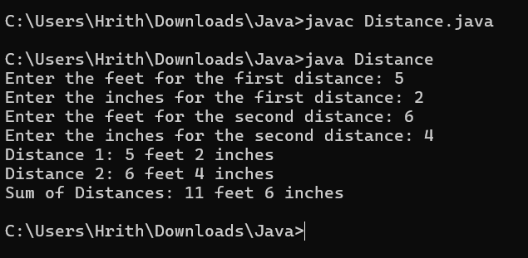
RESULT

Above program is successfully executed and its output is verified

PROGRAM:2

Date:08/08/2025
Write a Java Program to implement multilevel inheritance by applying various access controls to its data members and methods.

CODE

import java.util.Scanner;

// Base class
class Person {
private String name; // private - accessible only in this class
protected int age; // protected - accessible in subclasses
public String gender; // public - accessible everywhere

// Constructor
public Person(String name, int age, String gender) {
this.name = name;
this.age = age;
this.gender = gender;
}

// Public method to display personal info
public void displayPersonInfo() {
System.out.println("Name: " + name);
System.out.println("Age: " + age);
System.out.println("Gender: " + gender);
}

// Getter for private data
public String getName() {
return name;
}

// Added getter
public int getAge() {
return age;
}
}

// Derived class
class Employee extends Person {
protected String department;
private double salary;
public Employee(String name, int age, String gender, String department, double salary) {

super(name, age, gender);
this.department = department;
this.salary = salary;
}

// Protected method
protected void displayEmployeeInfo() {
System.out.println("Department: " + department);
System.out.println("Salary: $" + salary);
}

// Getter for private data
public double getSalary() {
return salary;
}

// Added getter
public String getDepartment() {
return department;
}
}

// Derived from Employee
class Manager extends Employee {
private int teamSize;

public Manager(String name, int age, String gender, String department, double salary, int teamSize) {
super(name, age, gender, department, salary);
this.teamSize = teamSize;
}

// Public method
public void displayManagerInfo() {
System.out.println("\n--- Manager Details ---");
displayPersonInfo(); // from Person
displayEmployeeInfo(); // from Employee
System.out.println("Team Size: " + teamSize);
}

// Added getter
public int getTeamSize() {
return teamSize;
}
}

// Main class
public class MultilevelInheritanceDemo {

public static void main(String[] args) {
Scanner sc = new Scanner(System.in);

System.out.print("Enter name: ");
String name = sc.nextLine();

System.out.print("Enter age: ");
int age = sc.nextInt();
sc.nextLine(); // consume newline

System.out.print("Enter gender: ");
String gender = sc.nextLine();

System.out.print("Enter department: ");
String department = sc.nextLine();

System.out.print("Enter salary: ");
double salary = sc.nextDouble();

System.out.print("Enter team size: ");
int teamSize = sc.nextInt();

// Creating Manager object with user input
Manager manager = new Manager(name, age, gender, department, salary, teamSize);

// Display details
manager.displayManagerInfo();

// Accessing data using getters
System.out.println("\nAccessing data using getters:");
System.out.println("Manager Name: " + manager.getName());
System.out.println("Manager Age: " + manager.getAge());
System.out.println("Manager Gender: " + manager.gender);
System.out.println("Manager Department: " + manager.getDepartment());
System.out.println("Manager Salary: $" + manager.getSalary());
System.out.println("Manager Team Size: " + manager.getTeamSize());

sc.close();
}
}
OUTPUT

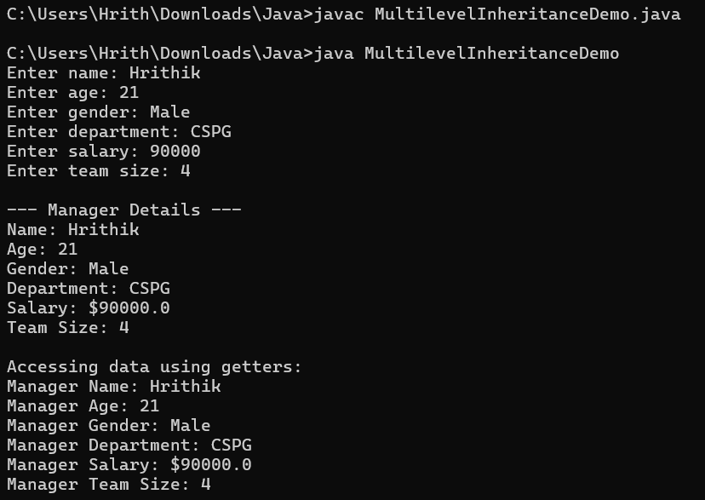

RESULT

The above program using multilevel inheritance and the access specifiers was implemented and the output is verified successfully.

PROGRAM:3
Date:18/08/2025

Write a JAVA Program to implement producer consumer problem using thread concept

CODE
class Buffer {
private int[] buffer;
private int count = 0;
private int size;

public Buffer(int size) {
this.size = size;
buffer = new int[size];
}

// Producer adds an item
public synchronized void produce(int item) throws InterruptedException {
while (count == size) {
wait(); // buffer full, wait for consumer to consume
}
buffer[count++] = item;
System.out.println("Produced: " + item);
notify(); // notify consumer that item is available
}

// Consumer removes an item
public synchronized int consume() throws InterruptedException {
while (count == 0) {
wait(); // buffer empty, wait for producer to produce
}
int item = buffer[--count];
System.out.println("Consumed: " + item);
notify(); // notify producer that space is available
return item;
}
}

class Producer implements Runnable {
private Buffer buffer;

public Producer(Buffer buffer) {
this.buffer = buffer;
}
public void run() {
int item = 0;

try {

while (true) {
buffer.produce(item++);
Thread.sleep(500); // simulate time to produce item
}
} catch (InterruptedException e) {
Thread.currentThread().interrupt();
}
}
}

class Consumer implements Runnable {
private Buffer buffer;

public Consumer(Buffer buffer) {
this.buffer = buffer;
}

public void run() {
try {
while (true) {
buffer.consume();
Thread.sleep(1000); // simulate time to consume item
}
} catch (InterruptedException e) {
Thread.currentThread().interrupt();
}
}
}

public class ProducerConsumerExample {
public static void main(String[] args) {
Buffer buffer = new Buffer(5); // buffer size 5

Thread producerThread = new Thread(new Producer(buffer));
Thread consumerThread = new Thread(new Consumer(buffer));

producerThread.start();
consumerThread.start();
}
}
OUTPUT

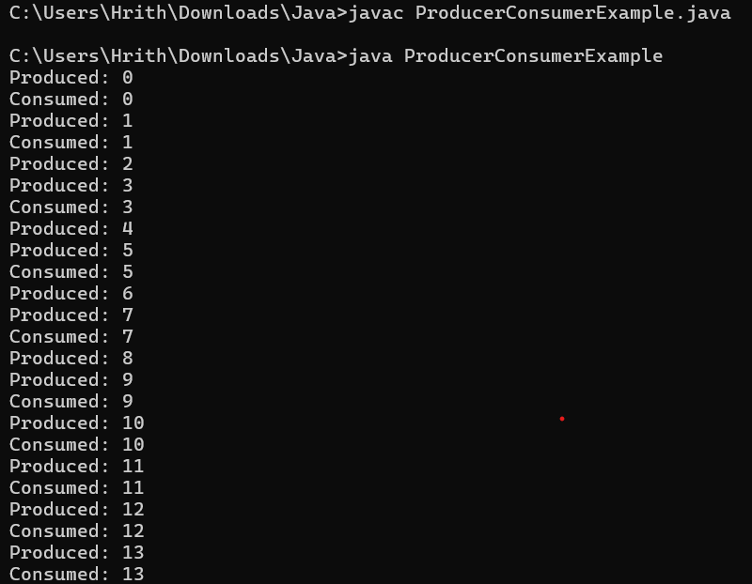

RESULT
Above program is successfully executed and its output is verified.

PROGRAM:4

Date:22/08/2025
Write a JAVA Program to Read 20 marks and store them in an array. Define your own exception name “Wrong Mark Exception” Throw and catch this type of exception when a mark is < 0 and mark is > 100.

CODE
import java.util.Scanner;

// Custom Exception Class
class WrongMarkException extends Exception {
public WrongMarkException(String message) {
super(message);
}
}
public class MarkProcessor {
public static void main(String[] args) {
Scanner scanner = new Scanner(System.in);
int[] marks = new int[20];

System.out.println("Enter 20 marks (between 0 and 100):");

for (int i = 0; i < 20; i++) {
try {
System.out.print("Enter mark for student " + (i + 1) + ": ");
int mark = scanner.nextInt();

if (mark < 0 || mark > 100) {
throw new WrongMarkException("Invalid mark: " + mark + ". Mark must be between 0 and 100.");
}

marks[i] = mark; // Store the valid mark
} catch (WrongMarkException e) {
System.out.println("Error: " + e.getMessage());
// Optionally, you can choose to re-prompt for the mark or skip this entry
// For this example, we'll continue to the next mark.
i--; // Decrement i to re-enter the mark for the current student
} catch (java.util.InputMismatchException e) {
System.out.println("Error: Invalid input. Please enter an integer value for the mark.");
scanner.next(); // Consume the invalid input
i--; // Decrement i to re-enter the mark for the current student
}
}
System.out.println("\nSuccessfully stored marks:");
for (int i = 0; i < marks.length; i++) {

System.out.println("Student " + (i + 1) + ": " + marks[i]);
}
scanner.close();
}
}

OUTPUT

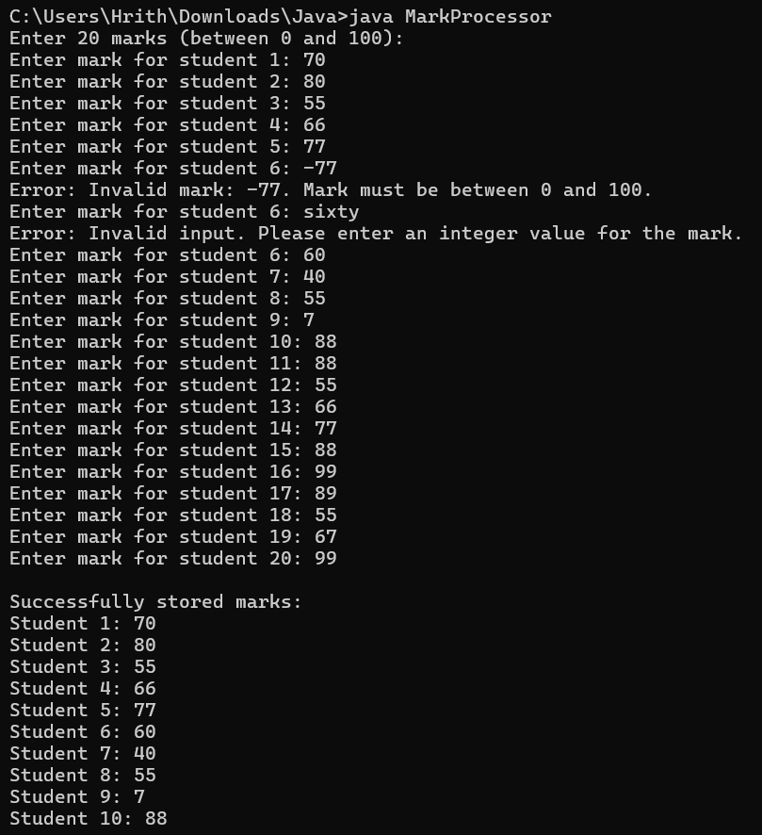
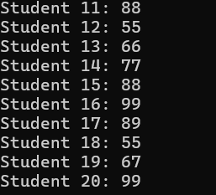

RESULT
Above program is successfully executed and its output is verified.

PROGRAM:5

Date:29/08/2025

Write a JAVA Program to create an interface named Shape2d that contains the declaration of a method double getArea(); define a subclass named Square that implements the interface Shape2d with data member side and methods Constructor() and getArea(). Create an object for the class Square and find the area.

CODE

import java.util.Scanner;

// Interface declaration
/* Shape2d is an interface with one abstract method getArea().
Any class that implements this interface must define the getArea() method. */
interface Shape2d {
double getArea(); // abstract method
}

// Square class implementing Shape2d
class Square implements Shape2d {
private double side;

// Constructor
public Square(double side) {
this.side = side;
}

/* Implement getArea() from Shape2d.
Square has a private data member side to store the length.
The getArea() method returns area using: Area = side × side. */
public double getArea() {
return side * side;
}
}

// Main class - driver class
public class Main {
public static void main(String[] args) {
Scanner sc = new Scanner(System.in);

// Taking user input
System.out.print("Enter the side of the square: ");
double side = sc.nextDouble();

// Create Square object
Square sq = new Square(side);

// Display area
System.out.println("Area of the square = " + sq.getArea());

sc.close();
}
}
OUTPUT

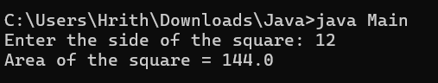

RESULT
Above program is successfully executed and its output is verified.

PROGRAM:6

Date:01/09/2025
Write a JAVA Program to Create a Swing program for Student Registration containing all the fields Name, Age, Contact, Father’s Name, Annual Income and a submit button. Perform field validations.

CODE

import javax.swing.*;
import java.awt.*;
import java.awt.event.*;

public class StudentRegistration extends JFrame implements ActionListener {
// Declare components
private JTextField nameField, ageField, contactField, fatherField, incomeField;
private JButton submitButton, resetButton;
private JLabel messageLabel;

public StudentRegistration() {
setTitle("Student Registration Form");
setSize(400, 400);
setDefaultCloseOperation(JFrame.EXIT_ON_CLOSE);

// Main panel (with form fields) using GridLayout
JPanel formPanel = new JPanel(new GridLayout(6, 2, 10, 10));
formPanel.add(new JLabel("Name:"));
nameField = new JTextField();
formPanel.add(nameField);

formPanel.add(new JLabel("Age:"));
ageField = new JTextField();
formPanel.add(ageField);

formPanel.add(new JLabel("Contact No:"));
contactField = new JTextField();
formPanel.add(contactField);

formPanel.add(new JLabel("Father's Name:"));
fatherField = new JTextField();
formPanel.add(fatherField);

formPanel.add(new JLabel("Annual Income:"));
incomeField = new JTextField();
formPanel.add(incomeField);
// Buttons panel
JPanel buttonPanel = new JPanel();
submitButton = new JButton("Submit");
resetButton = new JButton("Reset");
submitButton.addActionListener(this);
resetButton.addActionListener(this);

buttonPanel.add(submitButton);
buttonPanel.add(resetButton);

// Message label
messageLabel = new JLabel("", SwingConstants.CENTER);
messageLabel.setForeground(Color.RED);

// Wrap everything inside another panel to keep it centered
JPanel centerPanel = new JPanel(new BorderLayout(10, 10));
centerPanel.add(formPanel, BorderLayout.CENTER);
centerPanel.add(buttonPanel, BorderLayout.SOUTH);

// Add centerPanel to main frame with BorderLayout
setLayout(new BorderLayout());
add(centerPanel, BorderLayout.CENTER);
add(messageLabel, BorderLayout.SOUTH);

// Center the frame on screen initially
setLocationRelativeTo(null);
setVisible(true);
}

// Handle button clicks
public void actionPerformed(ActionEvent e) {
if (e.getSource() == submitButton) {
validateForm();
} else if (e.getSource() == resetButton) {
resetForm();
}
}

// Validation logic
private void validateForm() {
String name = nameField.getText().trim();
String ageText = ageField.getText().trim();
String contact = contactField.getText().trim();
String father = fatherField.getText().trim();
String incomeText = incomeField.getText().trim();

if (name.isEmpty() || ageText.isEmpty() || contact.isEmpty() || father.isEmpty() || incomeText.isEmpty()) {
messageLabel.setForeground(Color.RED);
messageLabel.setText("All fields are required!");
return;
}

int age;
try {
age = Integer.parseInt(ageText);
if (age <= 0 || age > 120) {
messageLabel.setForeground(Color.RED);
messageLabel.setText("Invalid age!");
return;
}
} catch (NumberFormatException ex) {
messageLabel.setForeground(Color.RED);
messageLabel.setText("Age must be a number!");
return;
}

if (!contact.matches("\\d{10}")) {
messageLabel.setForeground(Color.RED);
messageLabel.setText("Contact must be 10 digits!");
return;
}

try {
double income = Double.parseDouble(incomeText);
if (income < 0) {
messageLabel.setForeground(Color.RED);
messageLabel.setText("Income must be positive!");
return;
}
} catch (NumberFormatException ex) {
messageLabel.setForeground(Color.RED);
messageLabel.setText("Income must be a number!");
return;
}

messageLabel.setForeground(Color.GREEN);
messageLabel.setText("Registration Successful!");
}

// Reset form fields
private void resetForm() {
nameField.setText("");
ageField.setText("");
contactField.setText("");
fatherField.setText("");
incomeField.setText("");
messageLabel.setText("");
}

public static void main(String[] args) {
new StudentRegistration();
}
}
OUTPUT

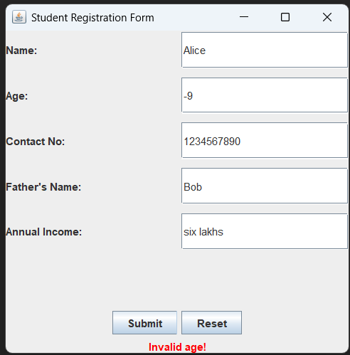
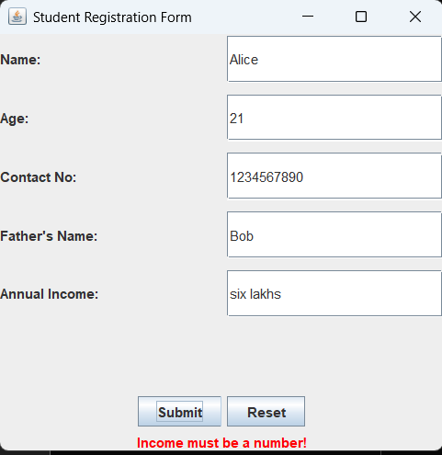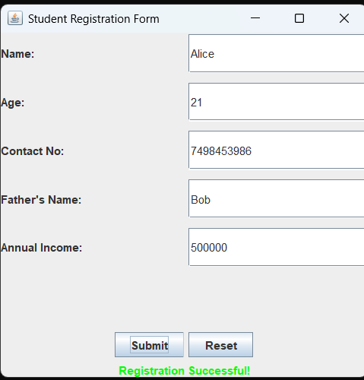

RESULT
The above Java Student Regsitration Program using Java Swings is implemented and the
output is verified

PROGRAM:7
Date:12/09/2025

Write a JAVA Program to implement Servlet program Reading form data using get and post methods

CODE
form.html
<!DOCTYPE html>
<html>
<head>
<title>Form Submission</title>
</head>
<body>
<h2>Submit Form Using GET or POST</h2>
<form method="GET" action="FormDataServlet">
<h3>GET Method</h3>
Name: <input type="text" name="name"><br>
Email: <input type="email" name="email"><br>
<input type="submit" value="Submit using GET">
</form>
<hr>
<form method="POST" action="FormDataServlet">
<h3>POST Method</h3>
Name: <input type="text" name="name"><br>
Email: <input type="email" name="email"><br>

<input type="submit" value="Submit using POST">
</form>
</body>
</html>

FormDataServlet.java
import java.io.IOException;
import java.io.PrintWriter;
import javax.servlet.ServletException;
import javax.servlet.annotation.WebServlet;
import javax.servlet.http.HttpServlet;
import javax.servlet.http.HttpServletRequest;
import javax.servlet.http.HttpServletResponse;
@WebServlet("/FormDataServlet")
public class FormDataServlet extends HttpServlet {
private static final long serialVersionUID = 1L;
@Override
protected void doGet(HttpServletRequest request, HttpServletResponse response)
throws ServletException, IOException {
String name = request.getParameter("name");
String email = request.getParameter("email");
response.setContentType("text/html;charset=UTF-8");
PrintWriter out = response.getWriter();
out.println("<html><body>");
out.println("<h2>Form Data Received via GET</h2>");
out.println("<p>Name: " + name + "</p>");
out.println("<p>Email: " + email + "</p>");
out.println("<br><a href='form.html'>Back to Form</a>");
out.println("</body></html>");
}
@Override
protected void doPost(HttpServletRequest request, HttpServletResponse response)
throws ServletException, IOException {
String name = request.getParameter("name");
String email = request.getParameter("email");
response.setContentType("text/html;charset=UTF-8");
PrintWriter out = response.getWriter();
out.println("<html><body>");
out.println("<h2>Form Data Received via POST</h2>");
out.println("<p>Name: " + name + "</p>");
out.println("<p>Email: " + email + "</p>");
out.println("<br><a href='form.html'>Back to Form</a>");
out.println("</body></html>");
}
}
OUTPUT

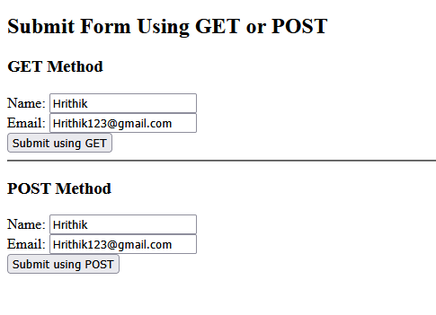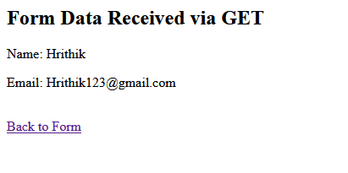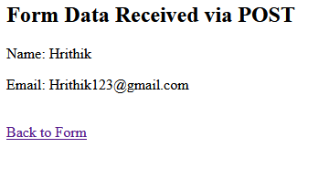

RESULT
The above Java Servlet Program to read data form using GET and POST method is executed
successfully.

PROGRAM:8

Date:29/09/2025
Write a JAVA Servlet program for HTTP status.

CODE

import java.io.IOException;
import java.io.PrintWriter;
import javax.servlet.ServletException;
import javax.servlet.annotation.WebServlet;
import javax.servlet.http.HttpServlet;
import javax.servlet.http.HttpServletRequest;
import javax.servlet.http.HttpServletResponse;
@WebServlet("/http-structure")
public class HttpStructureServlet extends HttpServlet {
private static final long serialVersionUID = 1L;
@Override
protected void doGet(HttpServletRequest request, HttpServletResponse response)
throws ServletException, IOException {
processRequest(request, response, null);
}
@Override
protected void doPost(HttpServletRequest request, HttpServletResponse response)
throws ServletException, IOException {
String param1 = request.getParameter("param1");
processRequest(request, response, param1);
}
private void processRequest(HttpServletRequest request, HttpServletResponse response, String param1)
throws IOException {
response.setContentType("text/html;charset=UTF-8");
try (PrintWriter out = response.getWriter()) {
out.println("<!DOCTYPE html>");

out.println("<html>");
out.println("<head><title>HTTP Structure Servlet</title></head>");
out.println("<body>");
out.println("<h2>HTTP Request Info</h2>");
out.println("<p>Method: " + request.getMethod() + "</p>");
out.println("<p>Request URI: " + request.getRequestURI() + "</p>");
out.println("<p>Protocol: " + request.getProtocol() + "</p>");
out.println("<p>Remote Address: " + request.getRemoteAddr() + "</p>");
if ("POST".equalsIgnoreCase(request.getMethod())) {
out.println("<hr>");
out.println("<h2>HTTP POST Data</h2>");
out.println("<p>Parameter 'param1': " + (param1 != null ? param1 : "Not Provided") + "</p>");
}
out.println("<hr>");
out.println("<h3>Send POST Request</h3>");
out.println("<form method='POST' action='" + request.getRequestURI() + "'>");
out.println("Param1: <input type='text' name='param1' />");
out.println("<input type='submit' value='Submit POST' />");
out.println("</form>");
out.println("</body>");
out.println("</html>");
}
}
}
OUTPUT

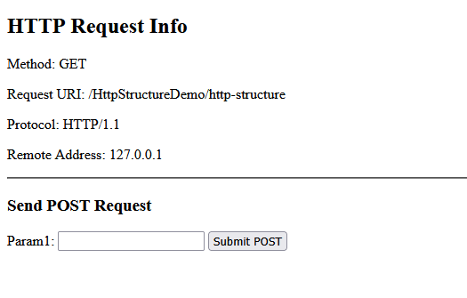

RESULT
Thus the Java Servlet program using GET and POST method is Executed and the Output is verified successfully.

PROGRAM:9
Date:03/10/2025

Write a JAVA Servlet program for Error Handling.

CODE
Index.html
<!DOCTYPE html>
<html>
<head>
<title>Exception Demo</title>
</head>
<body>
<h2>Trigger Different Exceptions with Input</h2>
<form method="post" action="ExceptionDemoServlet">
<label for="type">Exception Type:</label>
<select name="type" id="type" required>
<option value="">-- Select Exception Type --</option>
<option value="arithmetic">ArithmeticException</option>
<option value="numberformat">NumberFormatException</option>
<option value="nullpointer">NullPointerException</option>
<option value="arrayindex">ArrayIndexOutOfBoundsException</option>
<option value="classnotfound">ClassNotFoundException</option>
</select>
<br><br>

<label for="inputValue">Input Value:</label>
<input type="text" name="inputValue" id="inputValue" required />
<br><br>
<input type="submit" value="Trigger Exception">
</form>
</body>
</html>

ExceptionDemoServlet
import java.io.IOException;
import javax.servlet.ServletException;
import javax.servlet.annotation.WebServlet;
import javax.servlet.http.*;
@WebServlet("/ExceptionDemoServlet")
public class ExceptionDemoServlet extends HttpServlet {
protected void doPost(HttpServletRequest request, HttpServletResponse response)
throws ServletException, IOException {
String type = request.getParameter("type");
String inputValue = request.getParameter("inputValue");
response.setContentType("text/html");
try {
if (type == null || type.isEmpty()) throw new IllegalArgumentException("No exception type provided!");
switch (type) {
case "arithmetic":
int divisor = Integer.parseInt(inputValue);
int result = 100 / divisor;
response.getWriter().println("<h3>Result of 100 / " + divisor + " = " + result + "</h3>");
break;
case "numberformat":
int number = Integer.parseInt(inputValue);
response.getWriter().println("<h3>Parsed number: " + number + "</h3>");
break;
case "nullpointer":
String str = inputValue.isEmpty() ? null : inputValue;
int len = str.length();
response.getWriter().println("<h3>Length of input: " + len + "</h3>");
break;
case "arrayindex":
int[] arr = {10, 20, 30};
int idx = Integer.parseInt(inputValue);
int val = arr[idx];
response.getWriter().println("<h3>Value at index " + idx + " is " + val + "</h3>");
break;
case "classnotfound":
Class.forName("com.unknown." + inputValue);
response.getWriter().println("<h3>Class found (unexpected)</h3>");
break;
default:
response.getWriter().println("<h3>No valid exception type selected.</h3>");
break;
}
} catch (ArithmeticException e) {
response.getWriter().println("<h3>Caught ArithmeticException: " + e.getMessage() + "</h3>");
} catch (NumberFormatException e) {
response.getWriter().println("<h3>Caught NumberFormatException: " + e.getMessage() + "</h3>");
} catch (NullPointerException e) {
response.getWriter().println("<h3>Caught NullPointerException: " + e.getMessage() + "</h3>");
} catch (ArrayIndexOutOfBoundsException e) {
response.getWriter().println("<h3>Caught ArrayIndexOutOfBoundsException: " + e.getMessage() + "</h3>");
} catch (ClassNotFoundException e) {
response.getWriter().println("<h3>Caught ClassNotFoundException: " + e.getMessage() + "</h3>");
} catch (Exception e) {
response.getWriter().println("<h3>Some other exception caught: " + e.getMessage() + "</h3>");
}
}
protected void doGet(HttpServletRequest request, HttpServletResponse response) throws
ServletException, IOException {
response.getWriter().println("<h3>Please send a POST request with a 'type' and 'inputValue' parameter.</h3>");
}
}
OUTPUT

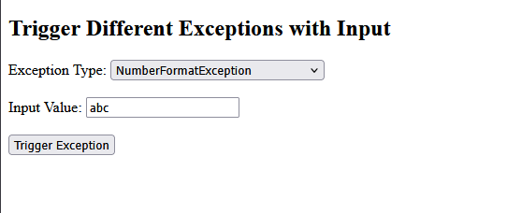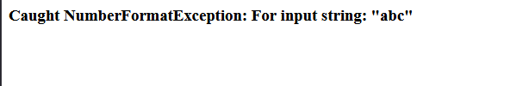

RESULT
The above Java Servlet Program for Exception Handling Mechanism is successfully executed and the output is verified.

PROGRAM:10

Date:13/10/2025
Write a JSP program to perform basic arithmetic functions.

CODE
<%@ page language="java" contentType="text/html; charset=UTF-8" pageEncoding="UTF-8"%>
<!DOCTYPE html>
<html>
<head>
<title>Basic Arithmetic Operations in JSP</title>
</head>
<body>
<h2>Basic Arithmetic Operations</h2>
<form method="post" action="arithmetic.jsp">
Number 1: <input type="text" name="num1" required><br><br>
Number 2: <input type="text" name="num2" required><br><br>
<input type="submit" value="Calculate">
</form>
<%
String num1Str = request.getParameter("num1");
String num2Str = request.getParameter("num2");
if (num1Str != null && num2Str != null) {
try {
double num1 = Double.parseDouble(num1Str);
double num2 = Double.parseDouble(num2Str);
double addition = num1 + num2;
double subtraction = num1 - num2;
double multiplication = num1 * num2;
String division;
if (num2 != 0) {
division = String.valueOf(num1 / num2);
} else {
division = "Cannot divide by zero";
}
%>
<h3>Results:</h3>
<p><b>Addition:</b> <%= addition %></p>
<p><b>Subtraction:</b> <%= subtraction %></p>
<p><b>Multiplication:</b> <%= multiplication %></p>
<p><b>Division:</b> <%= division %></p>
<%
} catch (NumberFormatException e) {
%>
<p style="color:red;">Please enter valid numbers!</p>
<%
}
}

%>
</body>
</html>
OUTPUT

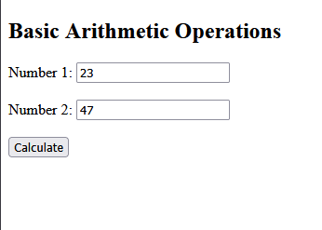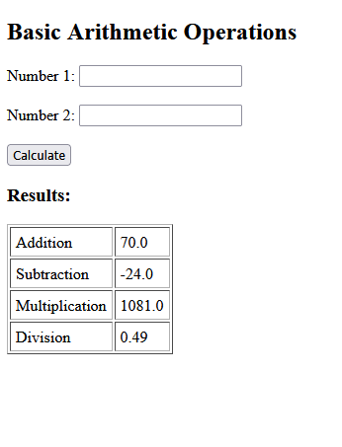

RESULT
The above JSP Program is executed successfully and output is verified.

PROGRAM:11

Date:24/10/2025
Write a JSP program to implement Expression Language.

CODE
<%@ page language="java" contentType="text/html; charset=UTF-8"
pageEncoding="UTF-8"%>
<!DOCTYPE html>
<html>
<head>
<title>Expression Language with User Input (Request, Session, Application Scope)</title>
</head>
<body>
<h2>User Input to Set Values in Different Scopes</h2>
<form method="post" action="ELScopes.jsp">
Enter Your Name (Request Scope): <input type="text" name="userName" required><br><br>
Enter Your Age (Session Scope): <input type="text" name="userAge" required><br><br>
Enter Application Name (Application Scope): <input type="text" name="appName" required><br><br>
<input type="submit" value="Submit">
</form>
<%
String userName = request.getParameter("userName");
String userAge = request.getParameter("userAge");

String appName = request.getParameter("appName");

if (userName != null && userAge != null && appName != null) {
request.setAttribute("userName", userName); // Request Scope
session.setAttribute("userAge", userAge); // Session Scope
application.setAttribute("appName", appName); // Application Scope
}
%>
<%-- Display values if submitted --%>
<% if (userName != null && userAge != null && appName != null) { %>
<hr>
<h3>Values Accessed via Expression Language (EL)</h3>
<p><strong>Request Scope - Name:</strong> ${userName}</p>
<p><strong>Session Scope - Age:</strong> ${userAge}</p>
<p><strong>Application Scope - App Name:</strong> ${appName}</p>
<p style="font-size: 0.9em; color: red;">
(Values are stored in different scopes and retrieved using EL.)
</p>
<% } %>
</body>
</html>
OUTPUT

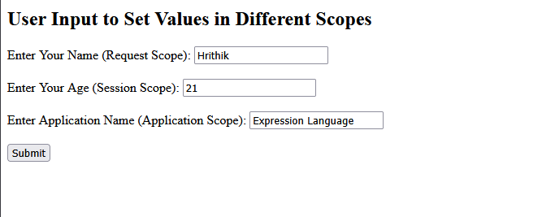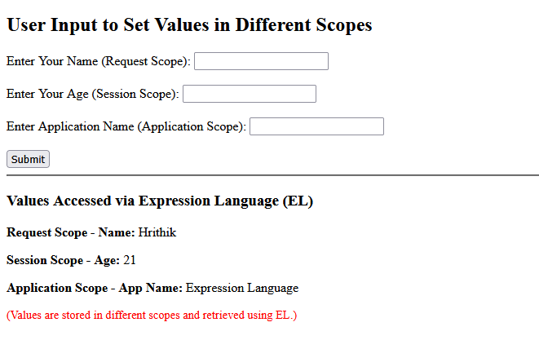

RESULT
The above program using JSP is successfully executed and output is verified.

PROGRAM:12

Date:03/11/2025
Write a program in JSP display the student mark list. Assume that student information is available in the database, which has been stored in a database server.

CODE
<%@ page import="java.sql.*" %>
<!DOCTYPE html>
<html>
<head>
<title>Student Marks</title>
</head>
<body>
<h1>Student Marks System</h1>
<%
Connection con = null;
String message = "";
try {
Class.forName("com.mysql.jdbc.Driver");
con = DriverManager.getConnection("jdbc:mysql://localhost:3307/testdb", "root", "root");
String action = request.getParameter("action");
if ("add".equals(action)) {
PreparedStatement ps = con.prepareStatement("INSERT INTO students VALUES (?, ?, ?)");
ps.setString(1, request.getParameter("roll_number"));
ps.setString(2, request.getParameter("name"));
ps.setInt(3, Integer.parseInt(request.getParameter("percentage")));
ps.executeUpdate();
message = "Student added!";
ps.close();
}
if ("update".equals(action)) {
PreparedStatement ps = con.prepareStatement("UPDATE students SET name=?, percentage=? WHERE roll_number=?");
ps.setString(1, request.getParameter("name"));
ps.setInt(2, Integer.parseInt(request.getParameter("percentage")));
ps.setString(3, request.getParameter("roll_number"));
ps.executeUpdate();
message = "Student updated!";
ps.close();
}
if ("delete".equals(action)) {
PreparedStatement ps = con.prepareStatement("DELETE FROM students WHERE roll_number=?");
ps.setString(1, request.getParameter("roll_number"));
ps.executeUpdate();
message = "Student deleted!";
ps.close();
}

} catch (Exception e) {
message = "Error: " + e.getMessage();
}

if (!message.isEmpty()) out.println("<h3>" + message + "</h3>");
%>
<h2>Manage Students</h2>
<form method="post">
Roll Number: <input type="text" name="roll_number"><br><br>
Name: <input type="text" name="name"><br><br>
Percentage: <input type="number" name="percentage"><br><br>
<button type="submit" name="action" value="add">Add</button>
<button type="submit" name="action" value="update">Update</button>
<button type="submit" name="action" value="delete">Delete</button>
</form>
<hr>
<h2>Student List</h2>
<table border="1">
<tr>
<th>Roll Number</th>
<th>Name</th>
<th>Percentage</th>
</tr>
<%
try {
Statement st = con.createStatement();
ResultSet rs = st.executeQuery("SELECT * FROM students");
while (rs.next()) {
out.println("<tr>");
out.println("<td>" + rs.getString("roll_number") + "</td>");
out.println("<td>" + rs.getString("name") + "</td>");
out.println("<td>" + rs.getInt("percentage") + "%</td>");
out.println("</tr>");
}
rs.close();
st.close();
con.close();
} catch (Exception e) {
out.println("<tr><td colspan='3'>Error: " + e.getMessage() + "</td></tr>");
}
%>
</table>
</body>
</html>
OUTPUT

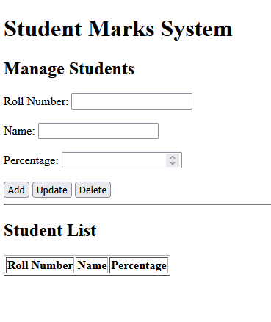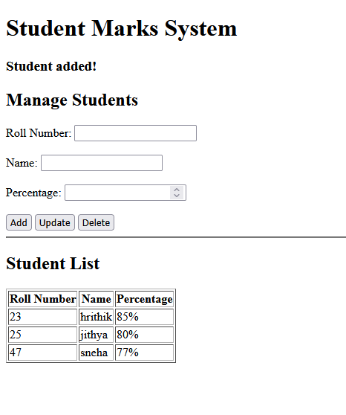

RESULT
The above program using JSP is successfully executed and output is verified.

